## Front End Engineering-II /Artificial

## Intelligence and Machine Learning

Project Report

Semester-IV (Batch-2022)

**Bloom - The Vibrant Blogging Platform**

**Supervised By: Submitted By:**

Mr. Rahul Sahil (2210992208)

Sahil 2210992211Sahil Saharan (2210992213)

Samiksha (2210992587)

**Department of Computer Science and Engineering**

## Chitkara University Institute of Engineering & Technology,

## Chitkara University, Punjab

**Abstract**

Bloom is a cutting-edge blogging platform designed to revolutionize content creation and digital storytelling. With a user-friendly interface and powerful customization options, Bloom enables bloggers, writers, and businesses to create visually stunning and engaging content with ease. The platform supports various media formats, including text, images, videos, and interactive elements, ensuring a rich and immersive reading experience.

Bloom is built for modern content creators, offering seamless social media integration, real-time collaboration, and AI-powered content recommendations to enhance engagement. Advanced analytics and SEO optimization tools empower users to maximize their reach and impact. Additionally, the platform prioritizes security and data privacy, ensuring a safe and reliable space for bloggers to share their ideas.

Designed for both beginners and experienced writers, Bloom fosters a thriving community where creators can connect, share insights, and grow their audience. With mobile-friendly accessibility and a vibrant ecosystem, Bloom is not just a blogging platform—it is a movement toward a more interactive and connected digital world.

**Table of Contents**  
**1. Introduction**

* 1. Background
  2. Objectives
  3. Significance

**2. Problem Definition and Requirements**:

2.1. Problem Statement

2.2. Software Requirements

2.3. Hardware Requirements

2.4 Data Sets

**3. Proposed Design/Methodology** :

3.1. System Architecture

3.2 Core features and Functionalities

3.3 Technology Stack

3.4 Development Methodology

3.5 Security Measure

**4. Results**:

4.1. Code Snippets

4.2 Project Snippets

**5. References**:

**1. Introduction**

**1.1 Background**

**The rise of digital media has transformed the way individuals and businesses share information, ideas, and stories. Blogging, which initially started as a personal journal-style format, has now evolved into a powerful medium for content creation, knowledge sharing, and digital marketing. Over the years, numerous blogging platforms have emerged, each offering unique features and capabilities. However, many of these platforms come with limitations such as complex user interfaces, limited customization, or inadequate engagement tools.**

**Bloom is a next-generation blogging platform designed to address these challenges and redefine the blogging experience. By combining intuitive design, multimedia support, and advanced analytics, Bloom enables users to create, customize, and distribute content effortlessly. Whether for personal storytelling, professional branding, or community engagement, Bloom provides a vibrant space for bloggers, writers, and businesses to thrive in the digital landscape.**

**1.2 Objectives**

**The primary objective of Bloom is to provide a seamless and engaging platform for content creators. The specific objectives of Bloom include:**

* **User-Friendly Interface: To develop an intuitive and accessible platform that allows users of all skill levels to create and publish content with ease.**
* **Customization and Personalization: To offer flexible design templates, themes, and layout options that empower bloggers to express their unique identities.**
* **Multimedia Integration: To support text, images, videos, and interactive elements, enhancing the storytelling and engagement capabilities of bloggers.**
* **SEO and Analytics Tools: To provide built-in SEO optimization and detailed analytics, helping users maximize their reach and improve content performance.**
* **Community Building and Social Integration: To enable seamless sharing across social media platforms and foster engagement through comments, discussions, and collaborative content.**
* **Security and Data Privacy: To implement robust security measures that protect user data and ensure a safe blogging environment.**
* **Monetization Opportunities: To offer features that allow bloggers to generate revenue through ads, subscriptions, sponsorships, and affiliate marketing.**
* **Cross-Device Accessibility: To ensure a mobile-friendly experience, allowing users to create, edit, and manage content from any device.**

**1.3 Significance**

**Bloom plays a crucial role in the evolving digital landscape, offering a solution that bridges the gap between traditional blogging and modern content creation needs. The significance of Bloom can be highlighted through the following key aspects:**

* **Empowering Creators: In an era where content drives influence, Bloom empowers individuals and businesses to build their online presence effectively.**
* **Enhancing Content Reach: With integrated SEO tools and social media connectivity, Bloom helps users reach wider audiences and increase visibility.**
* **Encouraging Digital Literacy: By simplifying content creation, Bloom encourages users to develop their digital skills and engage with online communities.**
* **Supporting Business Growth: Small businesses and entrepreneurs can leverage Bloom to establish thought leadership, drive engagement, and monetize their content.**
* **Creating an Inclusive Platform: Bloom aims to provide a space for diverse voices, fostering inclusivity and meaningful conversation**
* **s in the digital world.**
* **Adaptability to Trends: With the ever-changing nature of digital media, Bloom is designed to evolve with emerging trends, ensuring users always have access to the latest blogging innovations.**

**2. Problem Definition and Requirements**

**2.1 Problem Statement**

**The blogging landscape is saturated with platforms that often fail to provide a seamless, customizable, and engaging experience for users. Many existing solutions either lack intuitive interfaces, limit personalization, or do not offer integrated tools for engagement and**

**monetization. Additionally, issues related to data privacy, security, and content reach remain challenges for bloggers and content creators.**

**Bloom aims to address these issues by creating an all-in-one blogging platform that is user-friendly, feature-rich, and adaptable to evolving digital trends. The platform seeks to empower writers, businesses, and content creators by providing a space where they can efficiently produce, manage, and distribute their content while maximizing engagement and monetization opportunities.**

**2.2 Software Requirements**

**To ensure a robust and efficient blogging platform, Bloom will incorporate the following software requirements:**

* **Operating System: Windows, macOS, and Linux compatibility**
* **Frontend Technologies: ReactJS, HTML5, CSS3, JavaScript**
* **Backend Technologies: Node.js, Express.js**
* **Database Management: MongoDB or PostgreSQL**
* **Cloud Storage: AWS S3 or Google Cloud Storage for media file hosting**
* **Authentication and Security: OAuth 2.0, JWT authentication, SSL encryption**
* **SEO and Analytics: Google Analytics integration, built-in SEO tools**
* **Payment Gateway: Stripe or PayPal integration for monetization**
* **Content Management System (CMS): Custom-built CMS with WYSIWYG editor**
* **API Integration: Social media API for seamless content sharing**

**2.3 Hardware Requirements**

**To run and manage the Bloom platform effectively, the following hardware specifications are recommended:**

**1. Server Requirements:**

* **Minimum 4-core CPU (Intel Xeon or AMD equivalent)**
* **16GB RAM**
* **500GB SSD storage**
* **High-speed internet connection**
* **Load balancer for scalability**

**2. User Device Requirements:**

* **Minimum 2GB RAM (for desktop and mobile users)**
* **Latest web browser support (Google Chrome, Firefox, Safari, Edge)**
* **Stable internet connection for smooth content management**

**2.4 Data Sets**

* **Bloom will leverage various datasets to enhance user experience and content optimization:**
* **User Data: Profile information, blog posts, comments, likes, and shares**
* **Engagement Metrics: Page views, click-through rates, session duration**
* **SEO Data: Keyword rankings, metadata analysis, traffic sources**
* **Multimedia Content: Images, videos, audio files uploaded by users**
* **Advertising and Monetization Data: Ad impressions, revenue generation statistics**

**3. Proposed Design / Methodology**

**3.1 System Architecture**

**Bloom will be developed using a three-tier architecture consisting of:**

* **Frontend: A responsive and intuitive UI built using ReactJS for seamless user experience.**
* **Backend: A robust backend powered by Node.js and Express.js to handle user authentication, blog management, and interactions.**
* **Database: A scalable database (MongoDB) to store user profiles, blog posts, comments, and engagement metrics.**
* **Caching Layer: Redis to improve response time and optimize database queries.**
* **CDN Integration: Cloud flare or AWS Cloud Front for faster content delivery and security enhancements.**

**3.2 Core Features and Functionalities**

* **User Authentication: Secure login and registration using JWT authentication with OAuth integration for Google and Facebook sign-in.**
* **Content Creation & Management: A rich text editor allowing users to write, format, and publish blogs with image and video embedding.**
* **Categories & Tags: Users can categorize blogs and add tags for better discoverability.**
* **Engagement Features: Like, comment, share functionalities, and bookmarking for saving favorite blogs.**
* **Search & Filters: Advanced search and filtering options, including keyword-based, category-based, and popularity-based sorting.**
* **User Dashboard: A personalized dashboard for managing posts, drafts, reading lists, and engagement analytics.**
* **Admin Panel: Moderation tools for managing content, user reports, and activity logs.**
* **SEO Optimization: Automated meta-tagging, sitemap generation, and schema.org integration for better search engine ranking.**
* **Push Notifications: Real-time notifications for comments, likes, and new blog posts from followed authors.**
* **Monetization Options: Ad integration, premium content access, and affiliate marketing opportunities for bloggers.**

**3. 3 Technology Stack**

* **Frontend: ReactJS, Tailwind CSS, Next.js for server-side rendering.**
* **Backend: Node.js, Express.js**
* **Database: MongoDB with Mongoose ORM**
* **Authentication: JWT-based authentication with OAuth support**
* **Cloud Storage: AWS S3 or Firebase for media uploads**
* **Caching & Optimization: Redis for caching, ElasticSearch for advanced search functionalities.**
* **Message Queue: RabbitMQ or Kafka for handling asynchronous tasks like notifications and background jobs.**

**3.4 Development Methodology**

**Bloom will be developed following an Agile methodology, ensuring iterative development, continuous testing, and feedback-driven enhancements.**

* **Sprint Planning: Each sprint will span two weeks, covering feature development, testing, and deployment.**
* **Version Control: GitHub for collaborative code management with branching strategies.**
* **Testing: Unit testing (Jest), Integration testing (Postman), UI testing (Cypress) and Security Testing.**
* **Deployment: CI/CD pipeline with GitHub Actions or Jenkins for automated deployments.**
* **Performance Optimization: Load balancing with Nginx, database indexing, and lazy loading for media assets.**

**3.5 Security Measures**

* **Data Encryption: SSL/TLS encryption for secure communication.**
* **Role-based Access Control (RBAC): Different access levels for users, moderators, and admins.**
* **Content Moderation: AI-powered spam detection and manual moderation tools.**
* **DDoS Protection: Cloudflare integration to prevent malicious traffic attacks.**
* **Backup Strategy: Regular automated backups and disaster recovery plans.**
* **Logging & Monitoring: Centralized logging with ELK Stack and real-time monitoring using Prometheus and Grafana.**

**4. Result**

**4.1 Code snippets:**

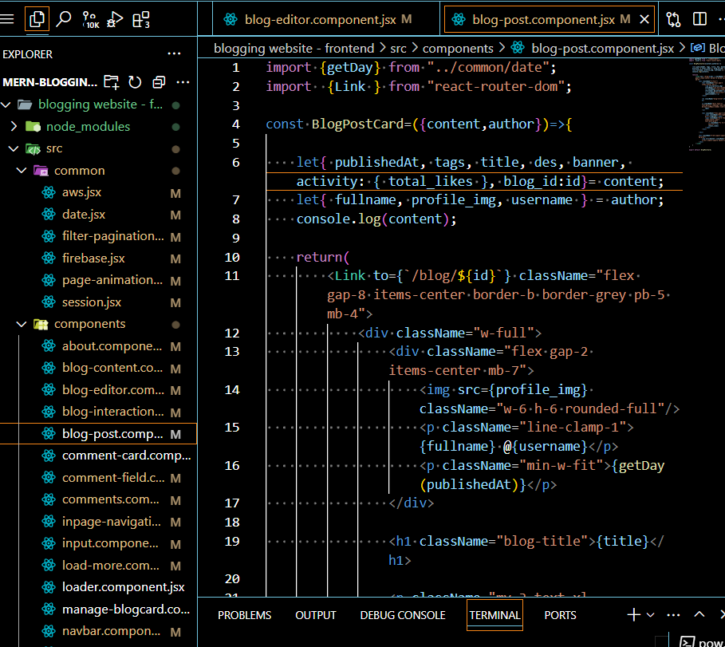

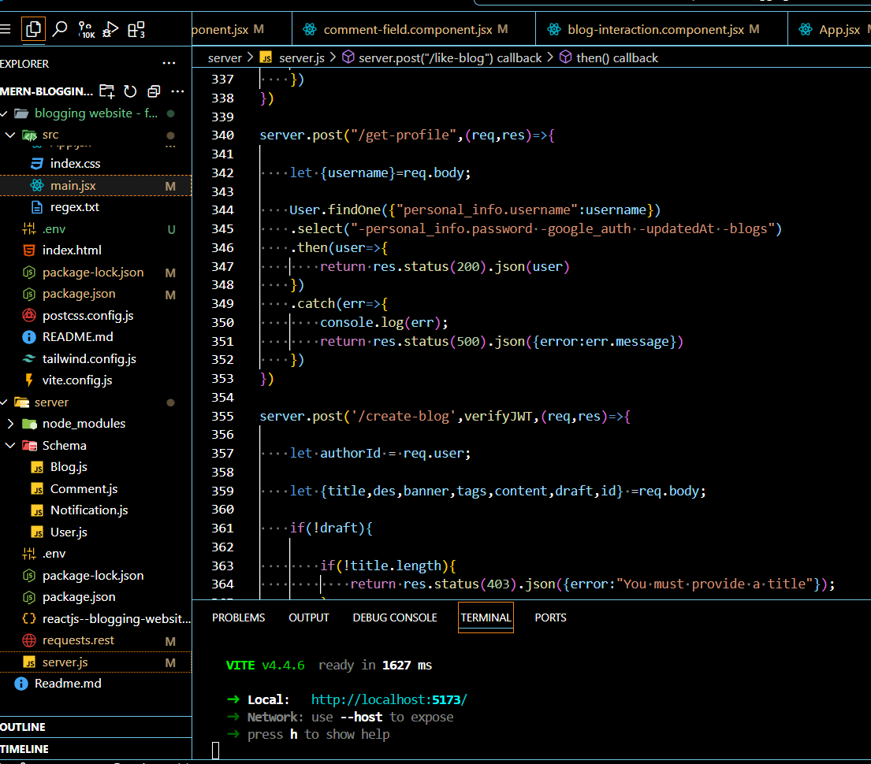

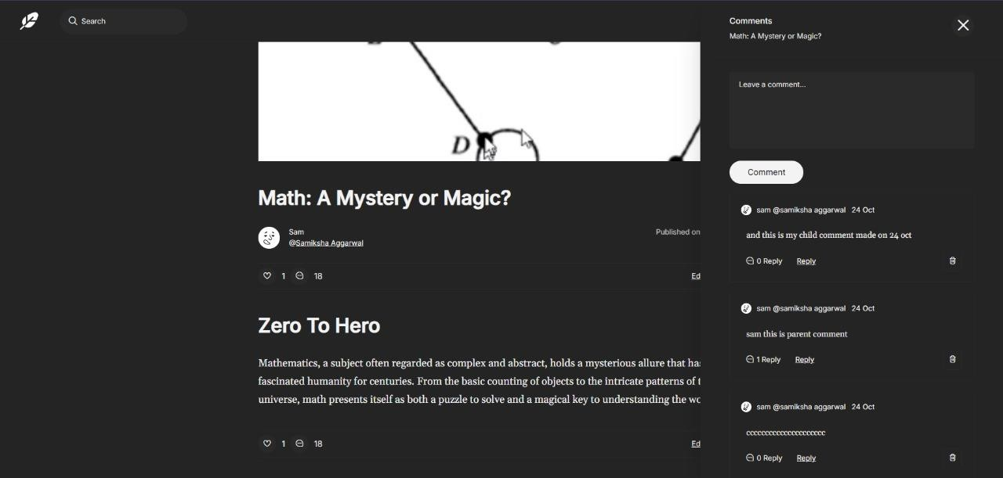**4.2 Project Snippets:**

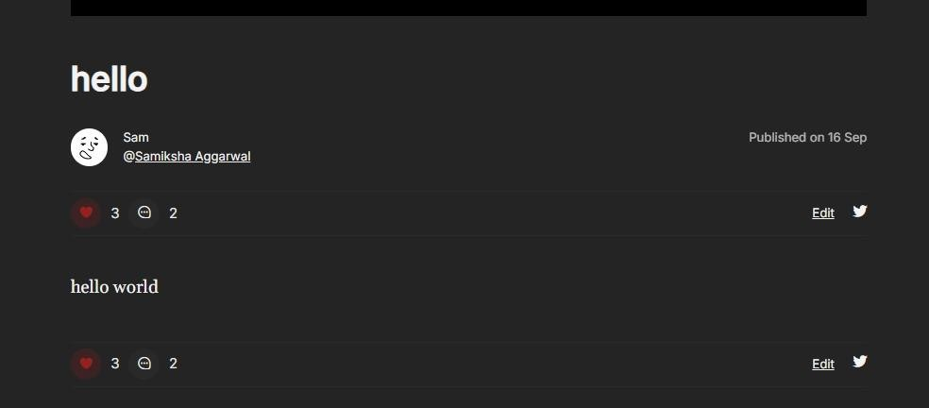

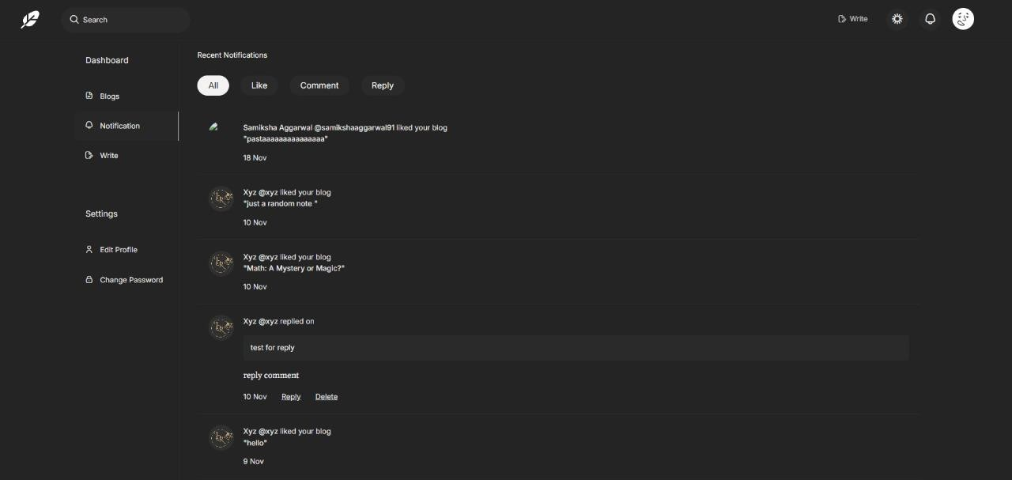

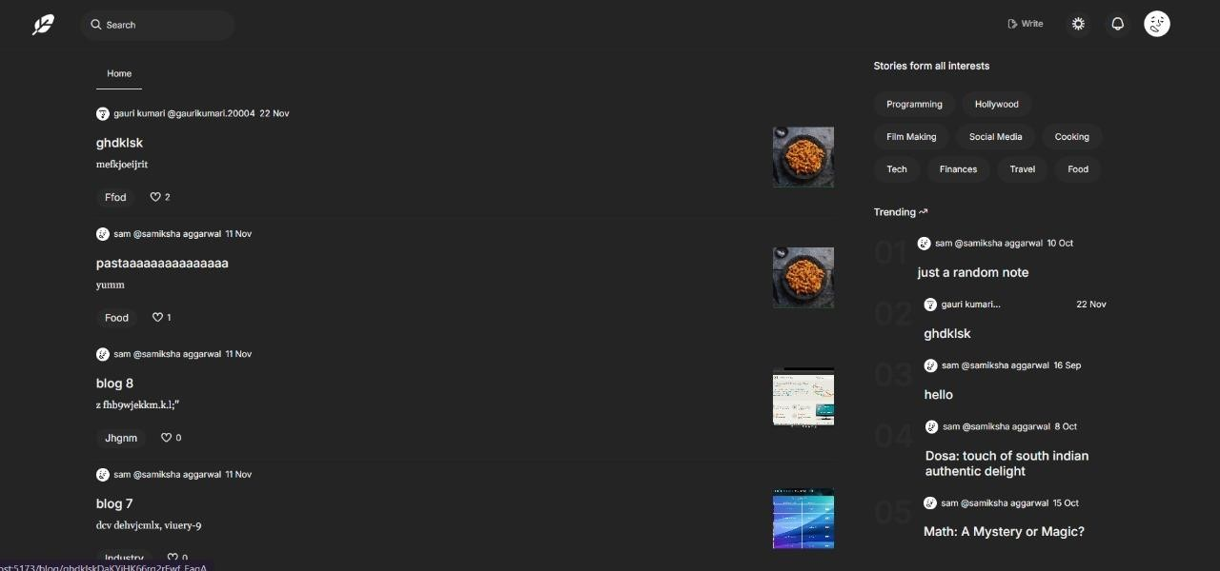

**5. References:**

* “Run JavaScript everywhere,” Nodejs.org. [Online]. Available: https://nodejs.org/en. [Accessed: 18-Sep-2024].
* “React,” React.dev. [Online]. Available: https://react.dev/. [Accessed: 18-Sep- 2024].
* “Express - Node.js web application framework,” Expressjs.com. [Online]. Available: https://expressjs.com/. [Accessed: 18-Sep-2024].
* “Documentation - Tailwind CSS,” Tailwindcss.com. [Online]. Available: https://v2.tailwindcss.com/docs. [Accessed: 18-Sep-2024].
* “Github Docs,” github.com Available: https://docs.github.com/en